**Software platform for implementation of online ordering of food in restaurants or cafes**

# Introduction

## Purpose

* This project is software platform for restaurants or cafés that allows integrating online functions into business processes.
* Integrating online services into business processes is actual task for the uprising income of small business in food service industry.
* At the present moment, the project has reached demonstration state.
* Other projects with the same functionality can be expensive and there is need for easy modified project.

## Industry/ domain

* The target industry of this project is food service business.
* After the covid crisis, food service business is fast growing industry with the Internet elements of business.
* Automatization of business processes in food service industry is key for growing income of business.
* This project can be used in other industries, which need online selling of goods.

## Stakeholders

* Restaurant staff can use this software in cycle of preparing orders.
* Online ordering allows reducing queue of clients before desk and increasing income of business.
* Restaurant staff can easy control of orders.

# Product Description

## Architecture Diagram

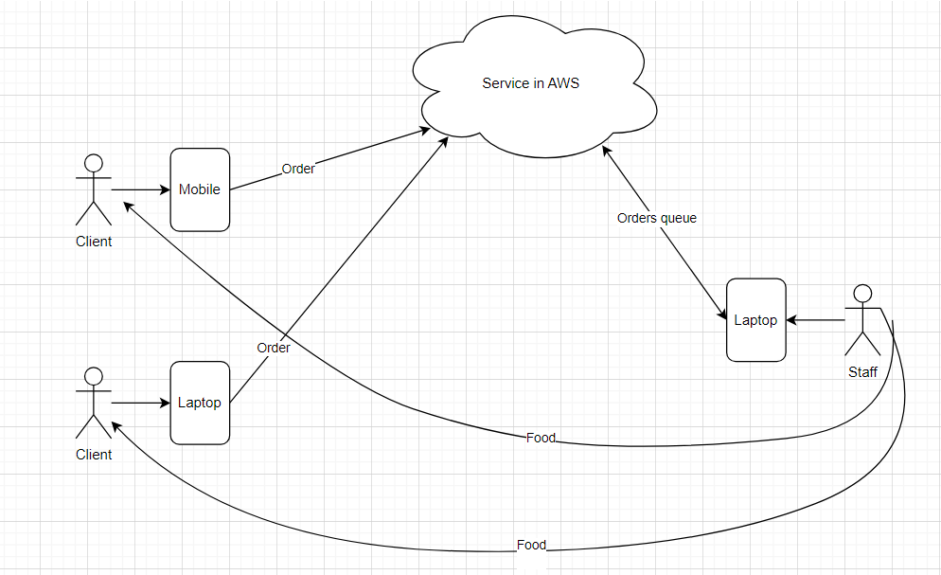

## User Stories

|  |  |  |  |  |
| --- | --- | --- | --- | --- |
| # | User Story Title | User Story Description | Priority | Additional Notes |
| 1 | Order by QR code | User pointes mobile phone on QR code of table, opens web page of café and makes order | 1 | Add support of QR code redirecting on café’s web site. |
| 2 |  |  |  |  |
| … |  |  |  |  |

## User Flow

Client flow diagram:

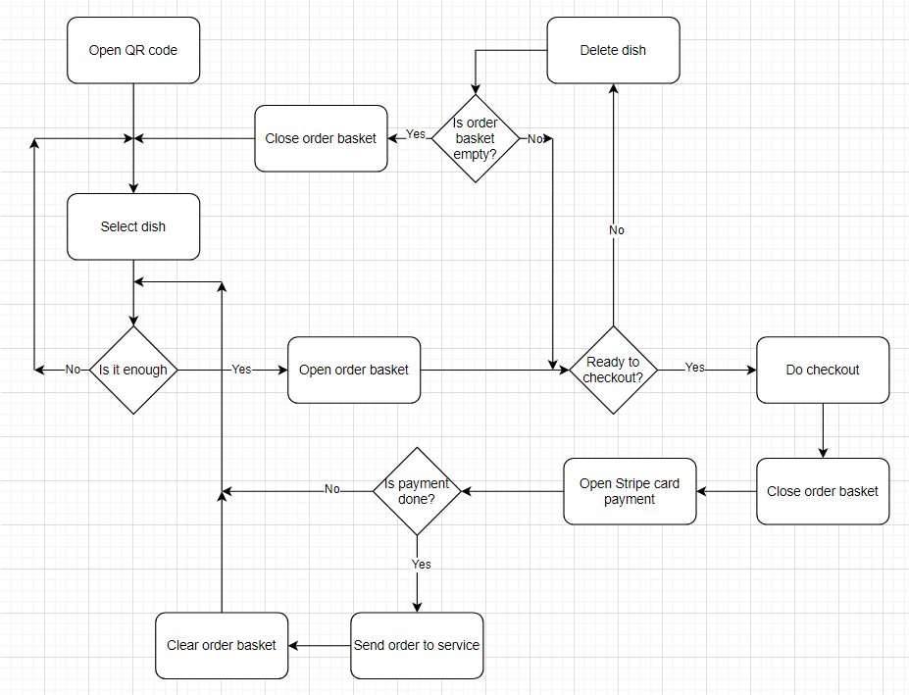

Staff flow diagram:

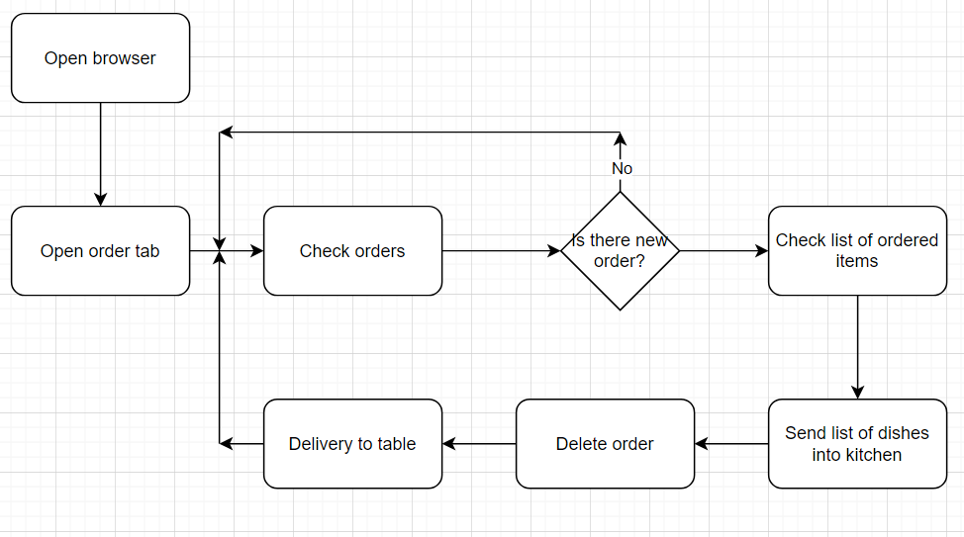

## Wireframe Design

Client user interface:

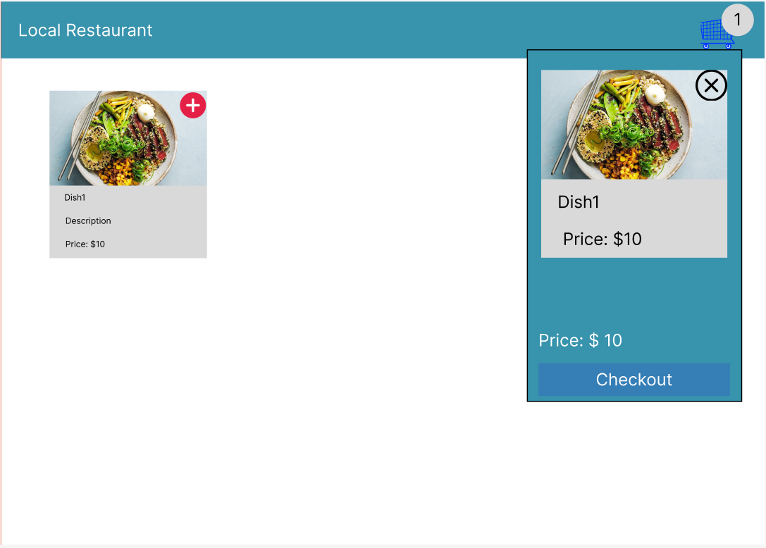

Staff user interface:

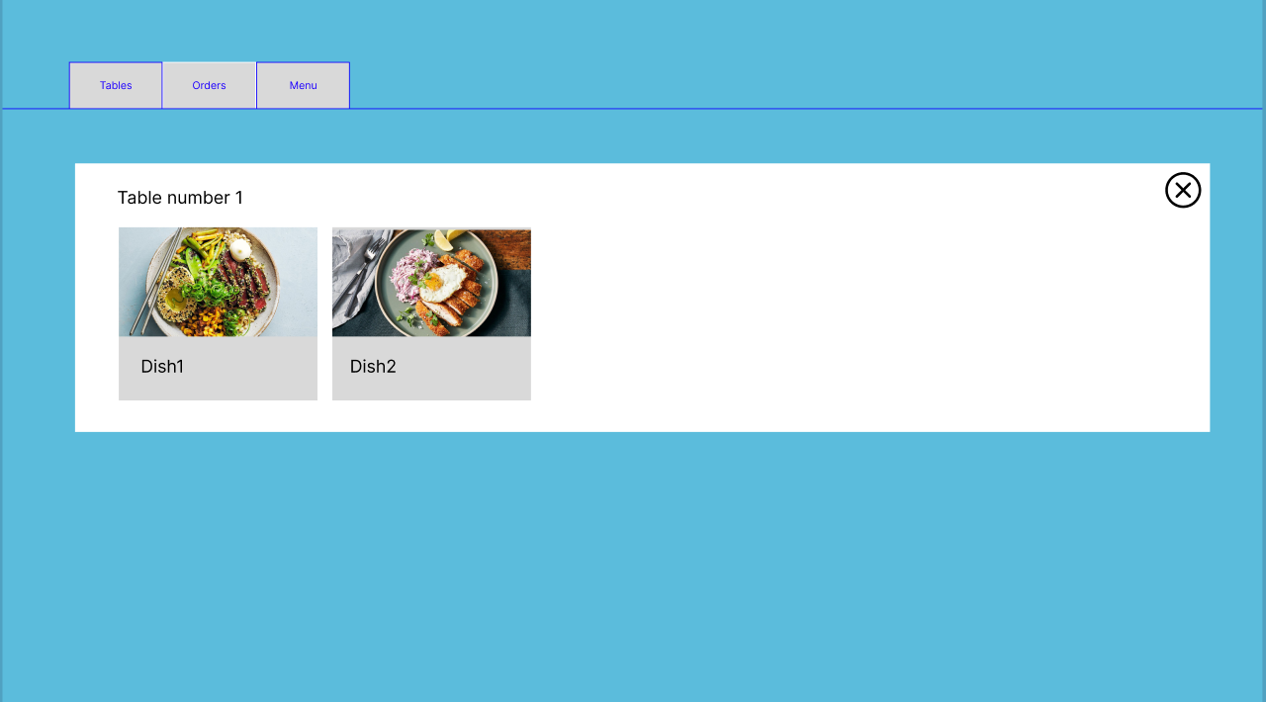

## Open Questions/Out of Scope

* Payment methods are out of scope

## Non-functional Requirements

* For security requirements, all payments are done by trusted service like Stripe.
* It must process at peak time up 20 many transactions every second.
* User with minimum experience of using web browser can use this software platform.
* This software must be stable work in cloud for demand of minimum between failures.

# Project Planning

# Testing Strategy

* Integration MVC has been done to achieve product quality.
* To test payment method by Stripe.

# Implementation

* The cloud platform AWS is considered for deploying of this software platform.

# End-to-end solution

* How well did the software meet its objectives?

# References

* Code of the project can be found by link: <https://github.com/EvgenyPereguda/CapstoneProject>
* In this project the next JavaScript libraries are used: express, dotenv, mysql2, sequelize, stripe, jest